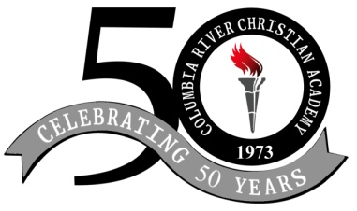
2

Columbia River Bible Church
Columbia River Christian Academy
1086 Hwy. 395 N.
Kettle Falls, Washington 99141
(509) 738-6632
E-Mail: secretarrymycrbc.org
www.mycrbc.org

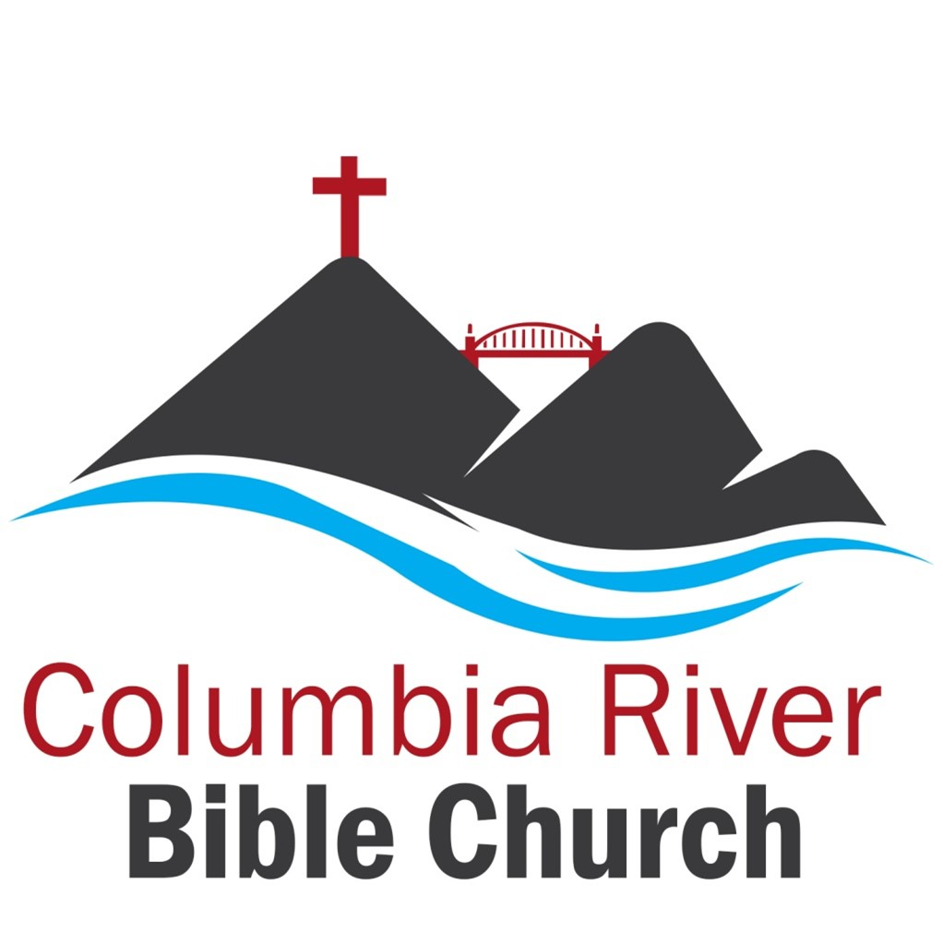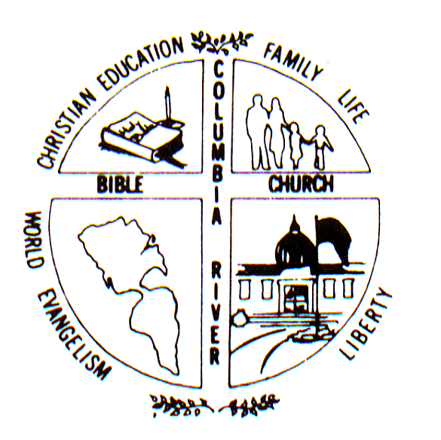

TUITION RATES
(Effective July 1, 2026)

ALL STUDENTS TUITION: 1st child : $300 month (9Payments) $2700 (yearly)
2nd child : $260 month (9 payments) $2340 (yearly)
3rd child+ : $230 month (9 payments) $2070 (yearly)

School Hours are Monday – Friday 8:20 – 3:00

Kindergarten: $275 (9 payments) monthly $2,475 (yearly)
School Hours: Mon - Thurs 8:30-3:00
Preschool : $250 (9 payments) monthly $2,250 (yearly)
School Hours: Mon.-Fri. 8:30-noon

PACE Fee: Grade 1st-4th $3.20 each (approximately $20-$25 per month)
5th - 7th $3.70 each
8th -12th $4.75 each

HOME SCHOOL: $115 flat rate per month for homeschool per student + cost of PACES

PACE Fee: Grade 1st – 4th $4.00 each
5th – 7th $4.35 each
8th – 12th $4.75 each

$35 for graduating Seniors at Graduation (billed in May)

New Enrollment: $60 per student
Re-Enrollment (if done by June 3rd) $20 per student
Re-Enrollment (if done after June 3rd) $60 per student

BUS COST: Per Trip $2.50 per student
Month $35.00 per student

Rates are subject to change.

